Chapter 10
- octet rule atoms share e’s to achieve
- an octet (8 e’s) in their valence shell
- strictly applies to Period 2 (Li → F) only

Drawing Lewis structures
1/ total # valence e’s
2/ skeleton of molecule with single bonds
- the central atom is generally the least electronegative
3/ octets for terminal atoms
4/ formal charges
5/ cancel adjacent +/- formal charges by
forming multiple bonds
6/ octet rule for Li →F (8 valence e’s max)
- If central atom is from period 3 or higher, then the octet rule can be broken

- free radicals: molecules with odd # valence e’s
  - NO
  - NO2

Bond Order & Bond lengths
Bond order – describes whether a covalent bond is single, double or triples
- Bond order increases as bond length decreases
Bond length – is the distance between the 2 centers of atoms joined by a covalent bond. A double bond b/w atoms is shorter than a single bond & a triple bond is still shorter.

- AXn molecules - no lone pair on central atom
  - identical ligands → regular geometry AXnEm molecules
- E = lone pair larger volume in valence shell stronger repulsions
  - → distorted / irregular geometry

Hlatt(LiF) is more negative than Hlatt(NaCl) because of the smaller ion sizes (see lecture notes)
Kp = PCO2/PCO2 and Ptotal = PCO + PCO2
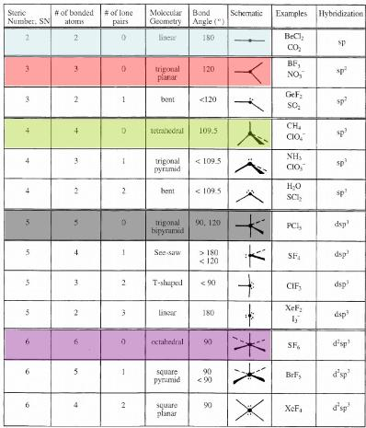

Molecular polarity
- equal e- sharing in homonuclear bonds → non-polar bonds H—H & Cl—Cl etc.
- unequal e- sharing in heteronuclear bonds → polar covalent
  - + H — Cl -
- electronegativity (Pauling 1920) ability of an atom to attract bonding e-’s EN increases as # of electrons increases & as atom size decreases
- bond polarity or ionicity increases as EN increases
- a polar bond has a dipole moment(u)
  - vectorial sum u(molecule) = Sum of u(bonds)
    - → molecular polarity depends on bond polarity + molecular geometry
  - molecules without polar bonds → u(molecule) = 0
    - molecules with polar bonds → polar ?
- symmetrical molecules are non-polar
  - AX2, AX3, AX4, AX5, AX6, AX2E3, AX4E2 – with identical ligands
  - um u(bonds) = 0
- Unsymmetrical molecules are generally polar
  - Sum u(bonds) is not equal to 0
- molecular polarity → intermolecular forces (dipole-dipole attractions)
  - physical properties: mp, bp vapour pressure
  - As polarity increases, boiling point increases

Bond energies
- The higher the bond order, the shorter the bond b/w 2 atoms & the greater the bond energy
- Energy is released when isolated atoms join to form a covalent bond & energy must be absorbed to break apart covalently bonded atoms.
  - Bond-dissociation energy, D, is the quantity of energy required to break 1 mole of covalent bond in a gaseous species (kJ/mol)
  - Average bond energy –is the average of bond dissociation energies for a number of diff. species containing the particular bond
- covalent bond energy = energy required to dissociate a molecule in the gas phase
- H2(g) → 2H(g) Enthalpy >0
- bond stability from balance
  - between e- …nuclei - attractions
  - nuclei … nuclei repulsions
  - e- … e- repulsions
- Generally when bond energy increases, bond order increases
- When bond energy increases, bond length decreases

Bond energies and change in H(rxn)
- for gas-phase reactions
  - change in H(rxn) = um of BE(reactants) - um of BE(products)
  - exothermic reactions when bonds in products are stronger than bonds in reactants
  - weak bonds (reactants) → strong bonds(products)
    - Change in H(rxn) < 0 therefore exothermic
  - Strong bonds (reactants) → weak bonds (products)
    - Change in H(rxn) > 0 therefore endothermic

Ionic bonding
- large electronegativity
- complete polarization formation of ionic bond

Chapter 15.1 – 15.6

